MINUTES OF THE DECEMBER 2024
MEETING OF THE GRADUATE COUNCIL

The Graduate Council held its regularly scheduled meeting on Wednesday, December 4, 2024 via ZOOM. Chair Alan Schick called the meeting to order at 3:30.

Members Present: Drs. Abernathy, Amidon, Barffour, Beckham, Bolyard, Buyurgan, Chang, Ennis, Friske, S. Hoelscher, Hulme, Jackson, Kaatz, Kageyama, Liu, Maher, McKay, McShan, Penkalski, Pszczolkowski, Roberts, Rose, Schick, Smith and Wickham; Ms. Dicke, Jones, Oetting, Pippa and Williams; Mr. Clouden and Turner
Members Absent: Drs. Bajalan, Chesman, Davis, Derayati, C. Hoelscher, Masterson, Mirza, Sakidja, G. Tapis, K. Tapis, Wehrman and Zimmerman; Ms. Chavez and Powell

Approval of Minutes

A motion was made by Dr. Smiths and seconded by Dr. Chang to approve the minutes from the November 2024 meeting. The minutes were unanimously approved.

Committee Reports

Report of the Council Chair – Alan Schick

No report.

Report of the Graduate Dean – Julie Masterson

- Announcements: For a complete listing of announcement and deadlines, see the “Graduate College Update” at http://graduate.missouristate.edu/facultystaff/Council.htm.

No report.

Report of the Graduate Student Senate –Kadesh Clouden

December 5 is the final event for the semester for students to get together for refreshments and social activities. GSS committees have been meeting and will meet again on Thursday, December 12th to plan for the Spring 2025 semester.

Report of the Graduate Faculty Membership Committee – Chloe Bolyard

The following departmental criteria was approved:

Psychology

The following faculty are approved for full graduate faculty status:

Mengming Michael Dong FERM Research
Nicholas Fierro-Martinez DSS Research
Derek Moser LIS Professional
Philip Ritcheson DSS Research
Chris Rodgers ART Research
The following faculty were approved for probational graduate faculty status:

Yasmine Singh LCR Research

Report of the Graduate Grievance Committee – Hilary Roberts

No report.

Report of the Graduate Scholarship Committee – Amy Hulme

The winner of the Distinguished Teaching Assistant Award was Whitney Owonubi Latture, TA in Communication, Media, Journalism and Film. Whitney’s information will be submitted to MAGS for the Excellence in Teaching Award.

Report of the Graduate Screening Committee – Melissa Penkalski

All proposals included in the Graduate Council December 4, 2024 agenda were approved.

Unfinished Business

None

New Business

None.

Open Mic

None.

Adjournment

The meeting adjourned at 3:38 p.m. The next meeting of the Graduate Council will be on January 15, 2024.

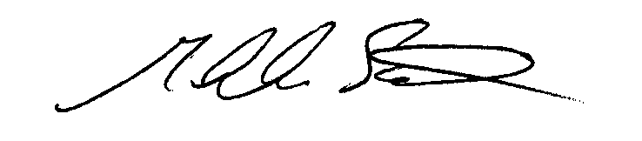

Alan Schick, Chairperson

